Hi Kevin,

Here is a documented approach that is optimized for rapid (speedy) data-entry.

Step 1) Browse to the web application:
http://xpd33500:8080/StampStorageWeb
alternate without DNS: http://10.44.1.78:8080/StampStorageWeb

Step 2) Click on “login” link at top-left of screen. Enter user/password: admin/admin

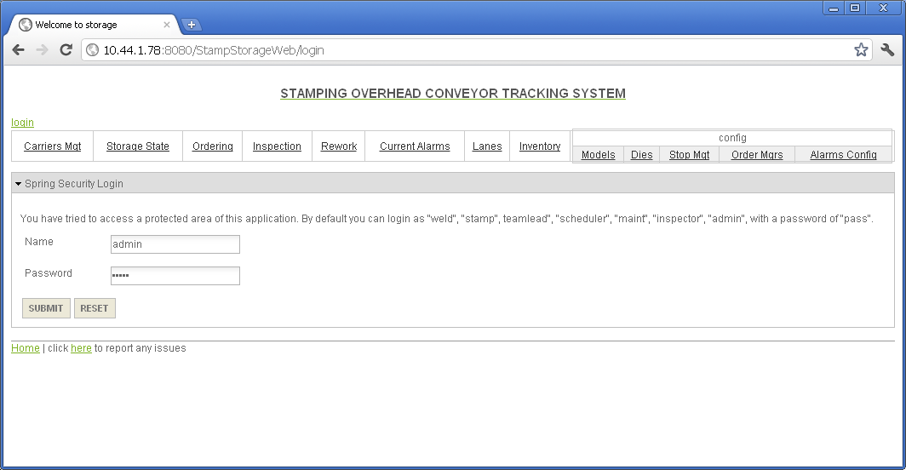
Step 3) Enter the following url in the address bar:
http://10.44.1.78:8080/StampStorageWeb/carriers/<carrier_number>?form where carrier_number is the carrier number like “1”. Change the following:
- Quantity (0 == empty, > 0 == not-empty)
- Current Location (Stop location of where the carrier is located)
- Destination (Stop location of where the carrier is going. Just use Current Location value for now).
- Die (666 = unknown parts, 999 = empty carrier)
- Buffer (1 == At gate of stop [aka front of line],
0 == Not at gate of stop [other carreries in front of it])
NOTE: Please ignore the following fields: Carrier Status, ProductionRunNumber, ProdRunTimestamp, reprocess
Then click the “SAVE” button.
Example:
http://10.44.1.78:8080/StampStorageWeb/carriers/1?form

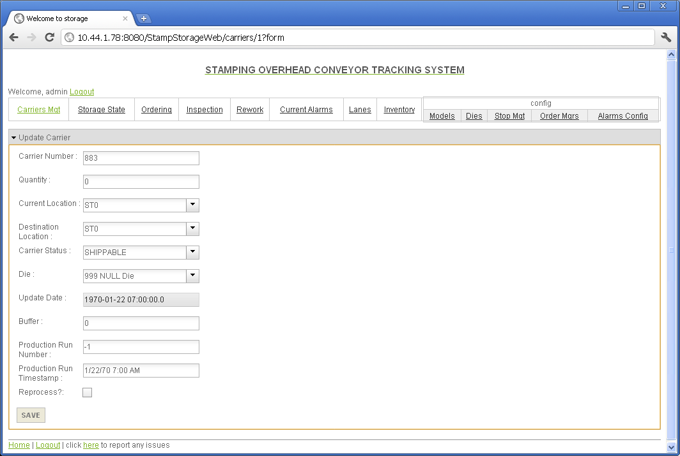

Step 4) After clicking the “SAVE” button, the next page (listing page) will show. Simply use the browser’s “BACK” button and change the carrier number in the address bar to the next carrier number you want to update.

I believe this will work. Please call if you have any issues.

Regards,
Jeff
CELL: 614.783.9451

